Linux Assginment 1  
  
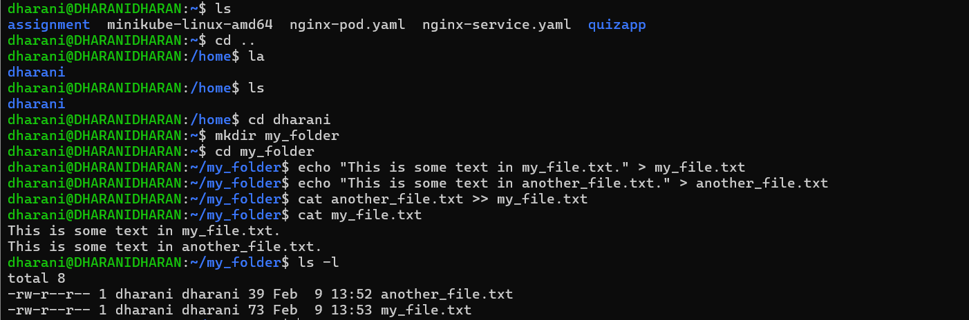  
  
2)Create 20 files with .txt extensions and rename the first 5 files to .yml extension and Print the latest created top 5 files among the total no of files"  
  
  
